1. **Agenda**:
   1. What is a **Topic**?
2. To understand queue, we took example of one-to-one chat in whatsapp but to understand **topic**, we will take an example of **group chat**.
3. **Whatsapp Example**:
   1. In group, what happens when a message is sent?
   2. The message goes to each member in the group.   
      So, this is kind of **Publish-Subscriber**.  
      So, we can say that all the members of the group are **subscribed** to the group.
4. **Youtube Channel:**
   1. When there is a new video or any other activities, all the subscribers will get notification.
5. **Let’s try to understand Topic:**
   1. Publisher: A Java App which publishes a message to a **Topic**.
   2. From the Topic, the message will be sent to each consumer (Java App).  
      So, we can say that all the consumers are subscribed to the **Topic**.
6. 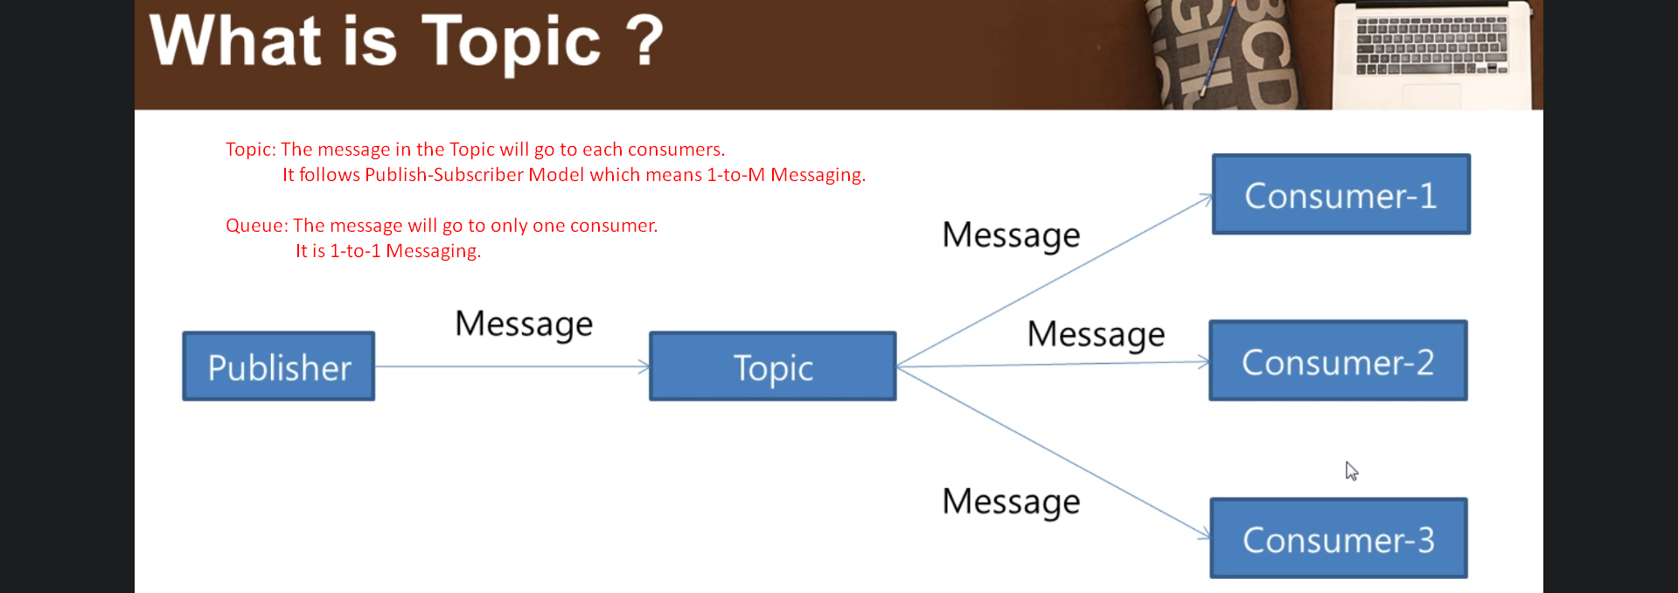

|  |  |
| --- | --- |
| **Queue** | **Topic** |
| One-To-One Messaging (1-to-1) | Publish-Subscriber Model (1-to-M) |